Application: Video Compression System
Aim
To analyze and compare the performance of three video compression algorithms having time complexities O(n log n), O(n^1.5), and O(n²) using asymptotic notation, and identify the most efficient algorithm for processing high-resolution video data.
Problem Statement
Video compression is an essential process in multimedia applications, online video streaming, video conferencing, and digital storage systems. Different compression algorithms require different execution times depending on the number of video frames being processed. This experiment compares three algorithms with different time complexities to determine which algorithm performs better for high-resolution videos containing a large number of frames.
Objectives
- To understand the concept of asymptotic analysis.
- To compare different algorithmic growth rates.
- To analyze the scalability of algorithms for large datasets.
- To identify the most efficient algorithm for real-world video compression.
Theory
Asymptotic notation is used to analyze the performance of algorithms as the input size increases. It helps compare algorithms independent of hardware and programming language.
The three commonly used asymptotic notations are:
Big O (O)
Represents the upper bound or worst-case running time.
Big Theta (Θ)
Represents the exact running time.
Big Omega (Ω)
Represents the lower bound or best-case running time.
The given algorithms have the following complexities:
- Algorithm A → O(n log n)
- Algorithm B → O(n^1.5)
- Algorithm C → O(n²)
Algorithm
Step 1
Read the number of video frames n.
Step 2
Calculate the estimated operations for
- Algorithm A = n log₂n
- Algorithm B = n^1.5
- Algorithm C = n²
Step 3
Display the calculated values.
Step 4
Compare all three complexities.
Step 5
Identify the algorithm having the smallest growth rate.
Step 6
Display the most efficient algorithm.
Source Code
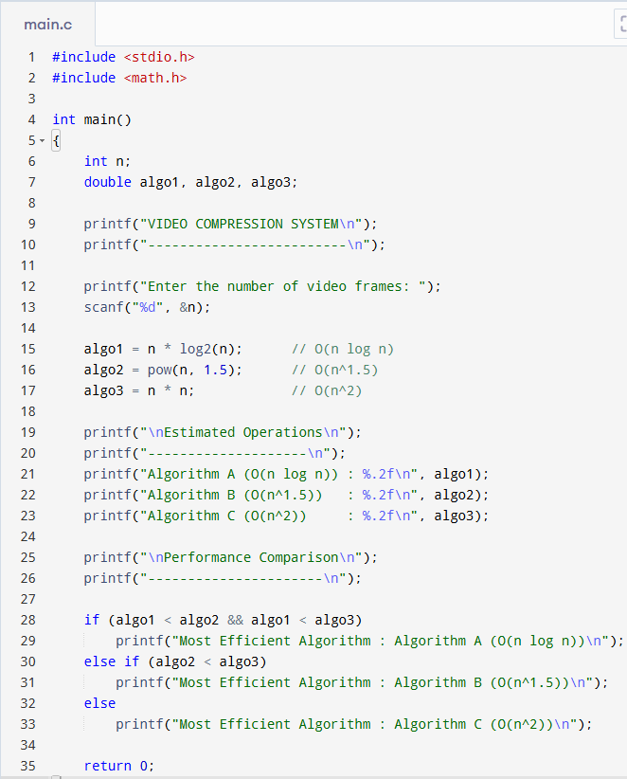
Output
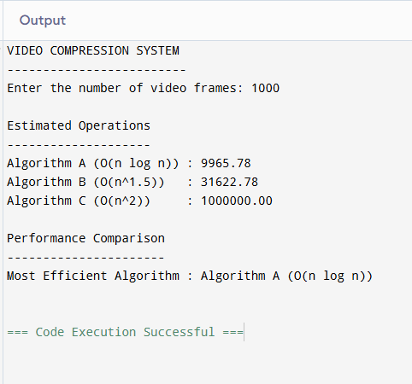
Example
Enter input size : 1000
Algorithm A = 9965.78
Algorithm B = 31622.77
Algorithm C = 1000000
Most Efficient Algorithm : O(n log n)
Analysis
Algorithm A
Complexity
O(n log n)
Θ(n log n)
Ω(n log n)
Growth is slow and suitable for processing millions of video frames.
Algorithm B
Complexity
O(n^1.5)
Θ(n^1.5)
Ω(n^1.5)
Growth is moderate.
Performance decreases gradually for large inputs.
Algorithm C
Complexity
O(n²)
Θ(n²)
Ω(n²)
Growth is very high.
Execution time increases rapidly for high-resolution videos.
Performance Comparison
Algorithm | Time Complexity | Relative Performance
A | O(n log n) | Excellent
B | O(n^1.5) | Good
C | O(n²) | Poor
Impact of Growth Rate
As video resolution increases, the number of frames and pixels also increases.
Algorithms with smaller growth rates require less processing time.
For example,
If
n = 1000
then
n log n ≈ 9966

n^1.5 ≈ 31623

n² = 1000000
The quadratic algorithm performs nearly one hundred times more operations than the logarithmic algorithm.
Therefore, higher growth rates reduce system performance significantly.
Result
Among the three algorithms,
O(n log n)
is the most efficient because it requires the least execution time and scales well for processing high-resolution videos.
Conclusion
The experiment demonstrates that algorithm efficiency depends on the growth rate rather than only the execution time for small inputs. Algorithms with lower asymptotic complexity perform better for large datasets. Hence, O(n log n) is the best choice for video compression systems.

